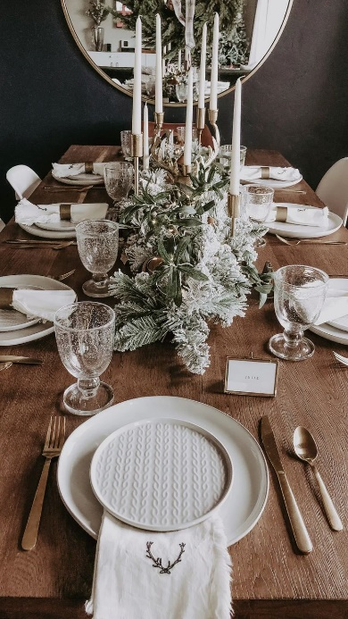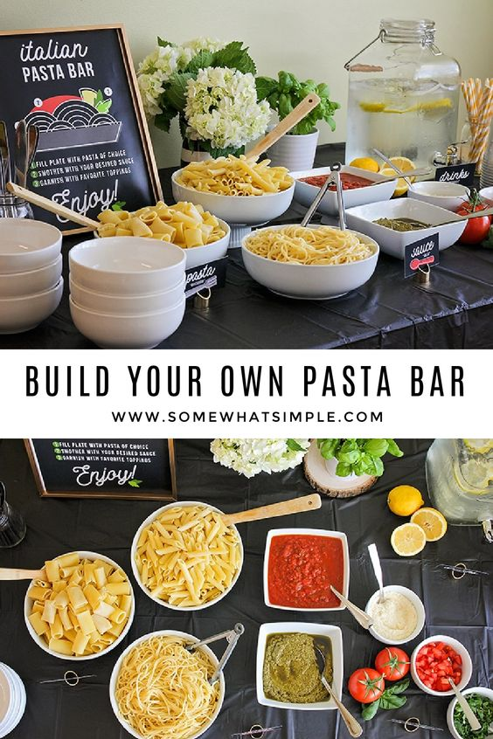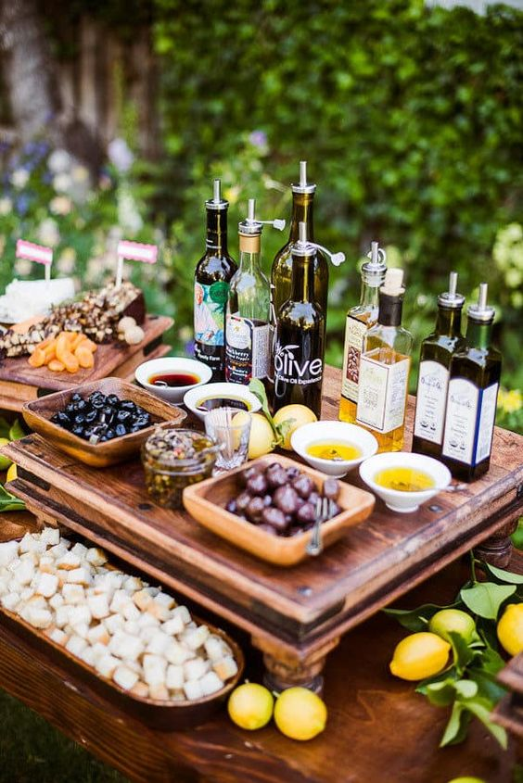
-Pick a date!
-Plan your menu and theme for the party (ideas below). Make sure to ask your guests for any food restrictions prior to attending
-Send out invites. Suggested amounts of 6-10 people.
- Based on number of attendees, plan and pick up supplies. (Glassware, napkins, serving dishes, décor, food, drinks)
-Plan out your signature party cocktail and give it a fun name
-Write out place cards and plan out seating arrangements
-Print out dinner menus and place them on the table prior to guests arriving
- Decorate the room with candles, a table runner, or other seasonal décor
- Set out straws, garnish, napkins
- Make individual appetizers or a cheese plate for a starter
-Put refreshments on ice. An idea is to put berries or sprigs of your favorite herbs into ice cube trays for extra fun drinks!
- Prep as much food as you can prior to guests arriving. When they get there, you should be putting the final touches on dishes. Keep your food warm by covering it or placing it in the oven on a low temperature
-Serve appetizers and drinks first
-Asks guest to be seated and serve the dinner, or if you are doing a serve yourself food bar, ask them to grab their plates and begin to serve themselves
-Make a toast during the dinner to thank your guests for attending
- Serve dessert if on the menu!

